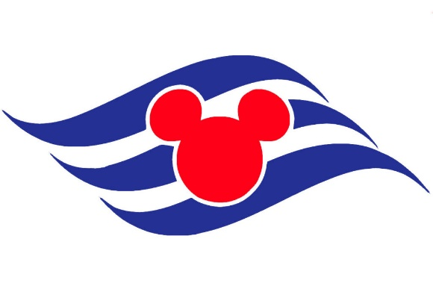
Our 1st Cruise
Disney Wonder-Alaska
June 26-July 3, 2017



